Fuel Up to Play 60 Grant Template

Fuel Up to Play 60 Grants provide the perfect funding source for Skillastics®. Skillastics provides products that;
- Standards and Evidence-Based
- Combines Physical Activity and Nutrition
- Engages up to 100 students of all ages and abilities at one time
- Flexible enough for PE, recess, or classroom use
- Students are MVPA 70%, with an average 142 bpm

Below we’ve outlined the overview of the Fuel Up to Play 60 Grants, and included ideas on how Skillastics products would fit perfectly in your grant application. If you have any questions, or would like more information, please contact Jess Wadleigh at jwadleigh@skillastics.com, or (310) 431-8205. Good Luck!

Overview:
- Up to $4,000 per school year is available to qualified K-12 schools enrolled in Fuel Up to Play 60 to jumpstart healthy changes.

Before You Begin:
Review the online 2016-17 Playbook to select one Healthy Eating Play and one Physical Activity Play. You will then request funding to help in implementing the Plays. (For your convenience, we’ve selected Healthy Eating Play: Highlight Healthful Foods – Everywhere in School, and Physical Activity Play: You Can Do It – We ALL Can!)

Process:
- Complete and submit the online application by Wednesday, June 15, 2015. CLICK HERE to get started today!
- Applicants receive notification of the funding decisions on your Fuel Up to Play 60 Dashboard within eight weeks after the Funding Deadline. Funding will be disbursed shortly thereafter.

Eligibility:
School must:
- Be enrolled in Fuel Up to Play 60 for the 2016-17 school year.
- Participate in the National School Lunch Program.
- Have a Program Advisor signed up at your school.
  - You may start the application before a Program Advisor is designated, but in order to submit your application, your school must have a Program Advisor signed up. You can sign up to be a Program Advisor directly on the online application on your Fuel Up to Play 60 Dashboard.
- If your school received Funds for Fuel Up to Play 60 in the past, your school must have submitted all required reporting in order to receive additional funding.

Application Assistance:
- You are encouraged to contact your Local Dairy Council with questions about the application process.
- For technical assistance with the application, contact the Fuel Up to Play 60 Help Desk via email or phone (800) 752-4337, 8:30 am to 5:00 pm ET, Monday-Friday.

General Info:
- The maximum amount of funding a school can receive for 2016-17 school year is $4,000, which can be divided among Healthy Eating and Physical Activity.
- Your application must include a plan for both Healthy Eating and Physical Activity
- The PE staff and School Nutrition staff, along with the Fuel Up to Play 60 Program Advisor should work together in selecting the Plays and developing this application. It is important that your plan demonstrates how your program, activities and the impact will continue beyond the year it is funded. In other words, you plan needs to be sustainable.

Funding Guidelines and Maximums for the School Year:
- The amount of funding requested for Physical Activity may not exceed the amount requested for Healthy Eating.
- Kickoff and Promotional Activities Max of $500 combined for both Healthy Eating and Physical Activity during one school year.
- Staff Stipends – Max of $400 total for internal staff and external professionals.
- No more than $300 of the allowable $400 may be devoted to internal staff stipends.
- Internal staff includes individuals at your school who are helping to implement your program
- Internal stipends are optional for your school to provide
- Outside professionals include outside trainers, speakers, and other outside personnel who assist with your Plays.
- Nutrition Education Materials: Max of $200
- Please apply only for the funding that your school needs and will use now, from $300 to $4,000. Funding should be used by the end of the 2016-17 school year.

Healthy Eating Plan:
- Your application must include a Healthy Eating Plan.
- Your Healthy Eating Plan should increase students’ access to and consumption of nutrient-rich foods, including fat-free and low-fat dairy, whole grains, fruits and vegetables.
- Remember that your application needs to explain how your Healthy Eating Plan is sustainable and will continue on after the school year in which it is funded.
- Funding for Healthy Eating may not be used;
  - To subsidize food or the cost of meals served to students in the school meals programs
  - For food sold to
- Before completing this section, please review:
  - Healthy Eating Plays in the 2016-17 Fuel Up to Play 60 Playbook
  - Funding Ideas Document
  - Components of Healthy Eating Patterns outlined by USDA’s 2015 Dietary Guidelines.

Application:

You identified the following Healthy Eating Play that you will be implementing at your school this year:

Highlight Healthful Foods Everywhere in School

How will funding be used to help accomplish your Healthy Eating Play?
(Include a description of the items, equipment and services you plan to purchase. These items should match those listed in your budget).

How will your Healthy Eating Plan encourage students to consumer more:

- Low-fat/Non-fat Dairy
- Fruits and Vegetables
- Whole Grains

How will your school promote your Healthy Eating Play? (check all that apply)

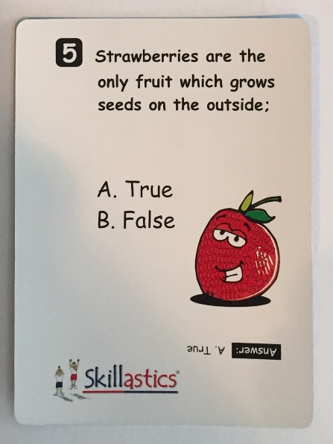
- Kickoff event -
- Promotional posters/signs/flyers –
Skillastics Nutritional Cards contain informative information that include bright and colorful illustrations. These cards could be enlarged and added to a bulletin board, in the lunch room and throughout the school. There are 90 questions all aligned with MyPlate.
- Morning announcements –
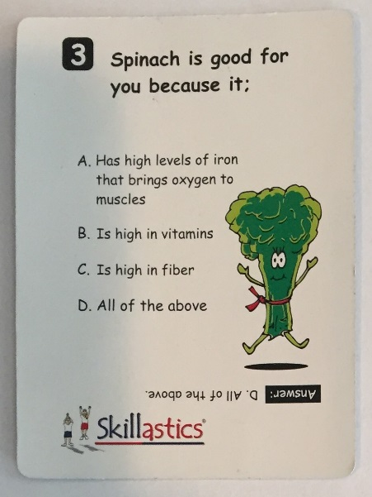
Health Questions of the Day. This can be done once a week or once a day, using the 90 different questions included with Skillastics Nutritional Cards. The announcer can ask the question, pause for thinking, and then reveal the answer.
- Social Media Posts –
It’s imperative that parents and members of the community have an opportunity to see what wonderful projects the school is promoting. Including the Skillastics Nutritional Card questions as an “informative” post, will allow parents to learn as well. For example, a post could be – “Did you know Strawberries are the only fruit which grows its seed on the outside”?

- Pep Rally –
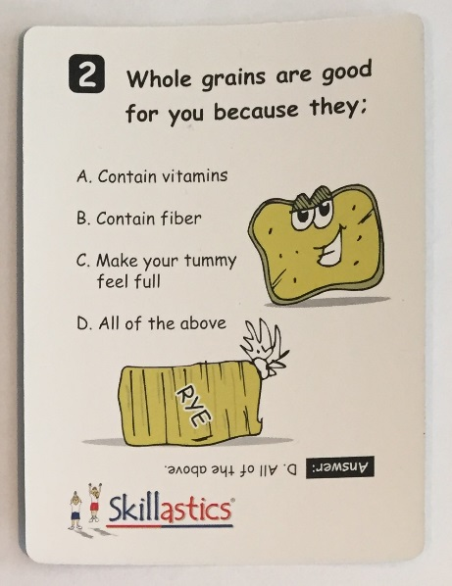
- Family Night –
Included is a guide on how you can run a Family Healthy Event Night. It contains step by step instructions on how to create a successful event.
- The program advisor can partner with the Kitchen Staff on providing healthy snacks during the event.
- Copies of the nutritional cards could be passed out to family members to take home as a reference.
- Family members can all participate in playing Fitness Skillastics, integrated with the Skillastics Nutritional Cards.
- Newsletter/Enews –
- Other –

What changes do you hope to see at your school this year as a result of implementing your Healthy Eating Play? (check all that apply)

- Students have increased access to healthy foods (low-fat/non-fat dairy, fruits & vegetables, whole grains)
- Students will consume more healthy foods
- More students participating in school breakfast
- More students participating in school lunch
- Students have an increased interest in healthy choices –
The more students are exposed to nutritional concepts repeatedly throughout the day, the more it will eventually resonate with them. Exposure is the key, and with 90 nutritional Cards that align with MyPlate, consistently being in front of them, students will positively respond.
- Positive change in student behavior (e.g. attendance rates, behavior referrals, visits to nurse, etc.) –
Research shows that children who eat healthier have more energy, have less behavioral and health issues. Creating an atmosphere of learning nutrition in a fun way, will lend itself to positive change.
- Overall healthier school environment –
Students are more apt to learn when learning is fun! Skillastics Nutritional Cards are a simple, fun way of learning nutritional concepts.
- More student leadership/teamwork –
Students are experiencing many underlying skills when using the Skillastics Nutritional Cards. There are numerous of ideas that are included with the Nutritional Cards that allow students to experience peer learning, leadership and teamwork skills.
- Other

Physical Activity Plan:

Notes:
- Your application must include a Physical Activity Plan, however, you are not required to request funding for your Physical Activity Plan.
- The amount of funding requested for the Physical Activity Plan MAY NOT exceed the amount of funding requested for the Healthy Eating Plan.
- Your Physical Activity Plan should increase students’ opportunities for participation in physical activity in school.
- Remember that your application needs to explain how your Physical Activity Plan is sustainable and will continue after the year in which it is funded.
- IMPORTANT: If you are applying for the Marathon Kids Physical Activity Play in this application your school must enroll/be enrolled in Let’s Move Active Schools.
- Before completing this section, please review.
  - Physical Activity Plays in the 2016-17 Fuel UP to Play 60 Playbook
  - Funding Ideas Document.

You identified the following Physical Activity Play that you will be implementing at your school this year.

You Can Do It – We All Can

How will funding be used to help accomplish your Physical Activity Play?
Include a description of the items, equipment and services you plan to purchase. These items should match those listed in your budget.

Describe any activity you will do to promote your Physical Activity Play. (check all that apply).
- Kickoff event –
- Promotional posters/signs/flyers –
Fitness, Fitness Xtreme, and Halfpint Skillastics include 5” x 7” Physical Activity Task Cards. Similar to the Skillastics Nutritional Cards, these cards can be enlarged and posted throughout the school. A hallway or breezeway could be designated as the “Physical Activity Trail”, and everyone in the school would have to do each of the Skillastics Physical Activities posted on the “trail” at least one time during a school day. Sustainability is key here. If students understand that this area is designated the “Physical Activity Trail” area, they would recognize that this is an area where they need to be active at least once every single day. There are numerous physical activities to choose from, so the activities could be replaced with new activities every week. If you wanted, you could also have a Skillastics Nutritional Card associated with each physical activity. The students would then have to complete the activity, answer the nutritional question, and then move on to the next physical activity, until they are all completed in the “trail”.
- Morning Announcements –
In the morning, teachers would discover in their box what Physical Activities would be covered in the morning announcements. The teacher would then review this activity with a student who would demonstrate for the class – preparing them for the announcement. During the announcements, the principal would mention the activity or activities, turn on some music, and all the students would participate in that activity until the music stops.

If your school has video announcement capabilities, the school can use the Instructional DVD’s that are included and provide that as a physical activity visual for the students to follow.

- Social Media Posts –
We will provide you with a Fitness Calendar that includes simple, quick physical activities a family can do together every single day of the month. The calendar can be posted on social media and in the School Newsletter or ENews letter.

- Pep Rally –
- Family Night –
  - The step by step guide on how to run a Family Fitness Event will be provided. You can provide information in this manual that can be included in the application. These ideas have been tested numerous times and have been proven to be extremely effective.
- Newsletter/eNews
- Other

What changes do you hope to see at your school this year as a result of implementing your Physical Activity Play? (check all that apply)
- Students have increased access to physical activity –
The “fitness trail” is one example of exposure and sustainability for increased access to physical activity.
- Positive change in student behavior (e.g. attendance rates behavior referrals, visits to nurse, etc.)
- Students have increased interest in wellness –
Skillastics is FUN! Students have fun when they don’t feel threatened in a physical active atmosphere. Skillastics is the perfect environment for this, allowing all children to have a positive experience being physically active.
- Overall healthier school environment –
It’s all about fun. Skillastics is simple to set up, easy to teach, and all children love participating in the technique of play.
- More student leadership/teamwork –
Skillastics can be described as an innovative technique of play that fully engages up to 100 children, of varying ages and abilities at one time. It helps students develop teamwork and leadership skills, as well as integrates academic components like Nutritional, while allowing them to be MVPA over 70% of the time. Every child gets to be a leader, and ALL children, no matter what their physical ability can participate. No team can advance, unless every single person on the team does the repetitions required together.
- Other

Skillastics®
Skillastics® is a series of oversize board games that help develop student’s fitness and sport skills. When combined with Skillastics Nutritional Cards, student’s experience a perfect balance of physical activity and nutritional learning fun!

Skillastics ties all the pieces together – activity, nutrition, and how students work together to establish fitness in a fun and active way that is easy-to-implement.

A challenge for most schools when trying to incorporate nutrition into the day is TIME. Skillastics® is viewed as a great way to quickly get children learning nutritional concepts aligned with MyPlate while simultaneously being physically active.

Skillastics was introduced in 2002, and is currently enjoyed by over 10 million students in more than 25,000 schools and after-school programs nationwide. Up to 100 children at one time can play Skillastics integrated with the Skillastics nutritional cards, and experience on average 70% MVPA and 142 bpm.

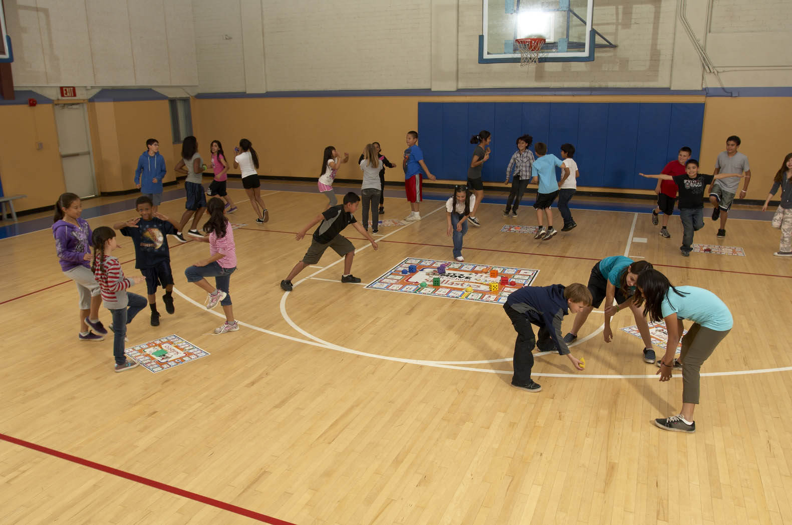

Budget –
- Skillastics Nutritional Cards (6 sets at $59.95/each, Total = $359.70) CLICK HERE for Video
  - One Set for Each Class Level
    - Skillastics Nutritional Cards include;
      - 90 questions that align with MyPlate
      - These 90 questions are broken down into 15 questions from each of the food groups (vegetables, fruits, protein foods, grains, dairy) and oils and empty calories (total 6 categories).
      - One complete set of the 90 questions are repeated a total of 6 times (total of 540 cards). Each set of 90 cards are colored coated differently (red, blue, green, orange, yellow, purple), and are stored in their own individual box.
      - All six boxes are stored in one big box.
      - Includes rules on how to integrate with Fitness Skillastics, and ideas on ways of using the Nutritional Cards alone.
  - The individual boxes that contain 90 questions, can be distributed to every class in that class level. (e.g. If your school has 5, 1st Grade Classes, one box could be distributed to each of the 5, 1st Grade Classes and you would then have one box left over).

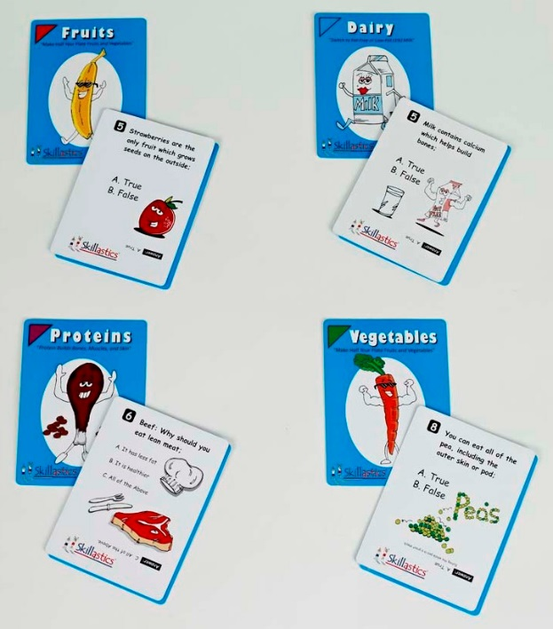
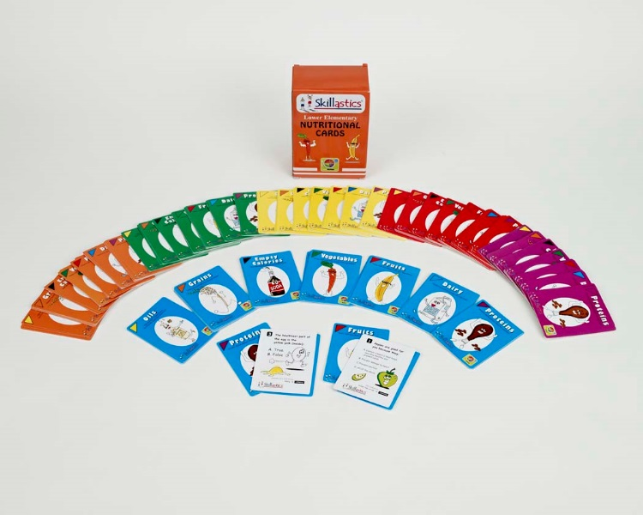
Skillastics Nutritional Cards

- Halfpint Skillastics (Physical Activity Game for Grades, K-1) – One Game - $109.95
CLICK HERE for Video
Includes:
    - One, 6” soft Shape Die
    - One, 6” soft Color Die
    - 36, 5” x 7” Age Appropriate Physical Activity Task Cards
    - Music CD – 72 tracks that include rhythms and melodies that mimic each of the 36 Physical Activities (one track would equal 30 seconds at a slow tempo of one of the activities. The 2nd track would equal 30 seconds at a fast tempo of the same activity).
    - Detailed Instructions
    - Convenient Backpack Carrying Case
    - Available in Both English and English/Spanish versions
  - The Halfpint Physical Activity Game can be shared throughout the school year by each Kindergarten and 1st Grade Class, or the Halfpint Skillastics Physical Activity Cards can be evenly divided among all the classes and rotated every couple of days.

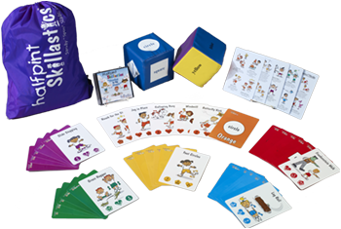

Halfpint – English Version

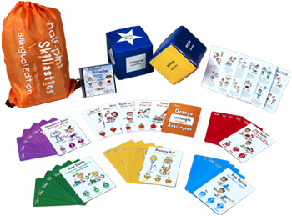

Halfpint – English / Spanish Version

- Fitness Skillastics (Physical Activity Game for Grades, 2-5) – Up to 100 children can play at one time. – One Game - $224.95 CLICK HERE for video. CLICK HERE to learn how to play Skillastics.
  - Can be used;
    - Before School
    - Recess
    - Brain Break (miniature mats can be used in a classroom environment)
    - After School
    - Family Fitness Event – (We include a manual on how to run a Family Fitness Night)
  - Fitness Skillastics;
    - Aligned with the National Physical Education Standards
    - Aligned with the Healthy Eating Physical Activity (HEPA) Guidelines
    - Allows children to be Moderately to Vigorously Physically Active (MVPA) over 70% of the time
    - Average heart rate: (142 bpm)
    - Integrates Skillastics Nutritional Cards into game play, combining a fun, physically active, learning environment.
    - Easy to set up and use
    - Can be used indoors or outdoors
  - Fitness Skillastics includes;
    - 1, 5’ x 7’ Vinyl Game Mat (includes 26 physical activities)
    - 6, 20” x 27” Vinyl Miniature Mats (identical to the large mat)
    - 6, multi-colored 3” die
    - 6, multi-colored 2” beanbag markers
    - 26, 5” x 7” laminated task cards
    - Instructional DVD
    - Instructional Manual
    - Convenient Backpack Carrying Case
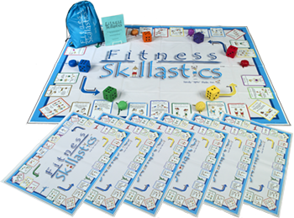
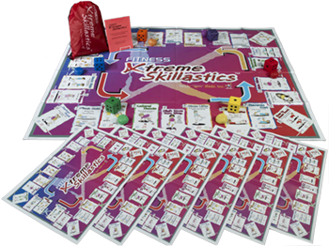

Fitness Skillastics Fitness Xtreme Skillastics
Total Budget: (3 options)
- Option 1:
  - Six (6) sets of Skillastics Nutritional Cards: $359.70
  - One (1), Halfpint Skillastics $109.95
  - One (1), Fitness Skillastics $224.95
Sub Total: $694.60
Shipping: $83.35
TOTAL: $777.95
(include tax in CA & WI only)
- Option 2:
  - Twelve (12) sets of Skillastics Nutritional Cards: $719.40
  - Two (2) Halfpint Skillastics: $219.90
  - Two (2) Fitness Skillastics: $449.90
Sub Total: $1,389.20
Shipping: $166.70
TOTAL: $1,555.90
(include tax in CA & WI only)

- Option 3:
    - Twenty (20) sets of Skillastics Nutritional Cards: $1,199.00
    - Three (3) Halfpint Skillastics: $329.85
    - Two (2) Fitness Skillastics and One (1) Fitness
Xtreme Skillastics (upgrade to the Fitness
Skillastics game – 26 new activities) $674.84
Sub Total: $2,203.69
Shipping: $264.44
TOTAL: $2,468.13
(include tax in CA & WI only)

